**AWS ASSIGNMENT-1**

Name : NAGURU MOUNIKA

Employee ID : 2320670

Cohort Code : CSDAIA24DB002

**How to Create an S3 Static Website ?**

**What is a S3 bucket in AWS?**

What is an Amazon S3 bucket? An Amazon S3 bucket is  a public cloud storage resource available in Amazon Web Services(AWS) Simple Storage Service(S3). It provides object-based storage, where data is stored inside S3 buckets in distinct units called objects instead of files.

**What are S3 buckets used for?**

Amazon's Simple Storage Service buckets are mainly used to help individuals and enterprises meet their data storage, backup and delivery needs in the cloud. An infinite amount of data can be stored and protected using Amazon S3 buckets for a variety of use cases:

* [Data lakes](https://www.techtarget.com/searchdatamanagement/definition/data-lake).
* Dynamic websites.
* Mobile applications.
* Backup and restore operations.
* [Big data analytics](https://www.techtarget.com/searchbusinessanalytics/definition/big-data-analytics).
* [User-generated content](https://www.techtarget.com/searchcio/definition/user-generated-content-UGC).
* Storage archives.
* Enterprise applications.
* [IoT devices](https://www.techtarget.com/iotagenda/definition/IoT-device).

**How to use an S3 bucket**

An S3 user first creates a bucket in the AWS region of their choice and gives it a globally unique bucket name. It's crucial to know that Amazon S3 buckets are globally unique, which means that the bucket names of any two AWS accounts in the same region can't be the same. AWS recommends that users choose regions geographically close to them to reduce [latency](https://www.techtarget.com/whatis/definition/latency) and storage costs.

**S3 bucket features :**

Amazon S3 offers numerous features to manage and organize data and support particular use cases. Commonly used features that can be enabled for S3 buckets include the following:

**Versioning control :** Versioning control can preserve every version of an object when a user performs an operation, such as copy or delete.

**Object Ownership.** This bucket-level setting can be used to disable ACLs and to take ownership of every object inside a bucket, streamlining access management for data stored in Amazon S3.

**Object replication.** The Amazon S3 Replication feature can replicate objects between buckets. Amazon S3 can be configured to automatically replicate S3 bucket objects across different AWS regions using S3 Cross-Region Replication(CRR).

**Transfer Acceleration**. This feature helps execute fast, secure transfers from a client to an S3 bucket via AWS [edge locations](https://www.techtarget.com/searchdatacenter/definition/edge-computing).

**Block Public Access.** A set of security controls called S3 Block Public Access ensures that the general public can't access S3 buckets and objects

**Audit logs.** A user can configure an Amazon S3 bucket to capture all access log entries made to it. These server access logs are great for auditing, as they keep track of every request made against a bucket or the objects it contains.

**Object tagging.** Users can restrict and manage access to S3 objects using the Amazon S3 Tagging feature. These tags are key-value pairs that can be added to, changed or removed from S3 objects at any point in their lifespan. They enable the creation of identity and access management ([IAM](https://www.techtarget.com/searchsecurity/definition/identity-access-management-IAM-system)) policies, the configuration of S3 lifecycle policies and the customization of storage metrics.

**Steps to Create S3 Website:**

**STEP-1**: Go to Create Bucket and give Bucket name.

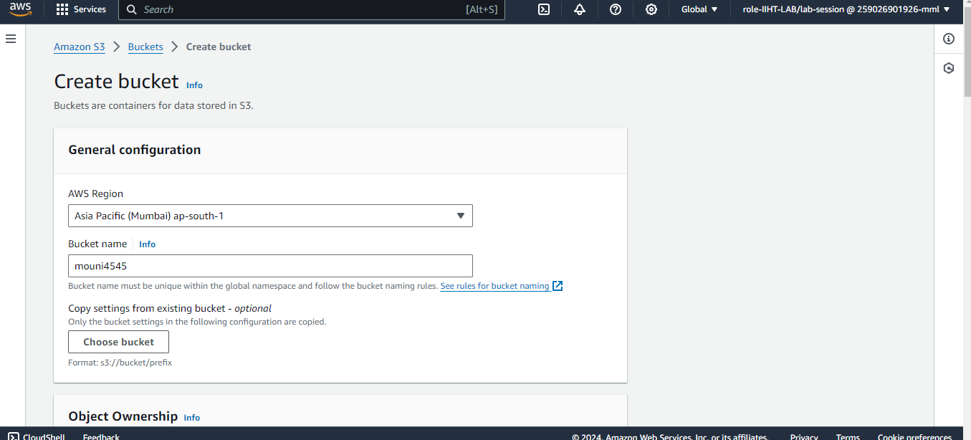

**STEP-2:** For Object Ownership ACL Enable i.e, Access to this Bucket and its Objects can be Specified using ACLs.

**STEP-3:** Turning Off for Block all Public Access.

**STEP-4:** Tick it for Acknowledge the current settings in the bucket .

**STEP-5:** Encryption type Enable and bucket key Enable and Create Bucket.

**STEP-6:** Bucket Created Successfully.

**STEP-7:** Go to Upload and Add Files to the Bucket And Upload it.

**STEP-8:** All Objects are Uploaded Successfully.

**STEP-9:** Go to Bucket and go to Properties.

**STEP-10:** Go to Enable Static Website hosting.

**STEP-11:** Give index Documents as index.html and save changes .

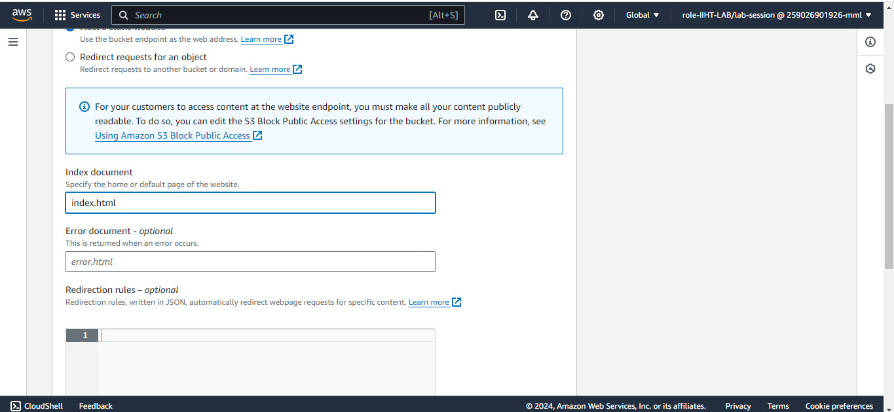**STEP-12:** Copy the link for Static Website hosting .

**STEP-13:** Paste the link in browser and Its Showing 403 Forbidden Error because it does not give access as Make Public using ACL .

**STEP-14:** For this Giving Public Access Select all Objects and make Public Access using ACL and click Make Public .

**STEP-15:** Refresh that Link in the Browser and website is Opened. And Created S3 Static Website Successfully.

